
A
Clean and Green Programme
on
“CLEAN INDIA GREEN INDIA”
(OR)
“SWACHH BHARAT ABHIYAAN”

Organised By

DEPARTMENT OF PHYSICS

Date: 24-11-2021
&
27-11-2021

Venue: Garden & Class Roooms

Department of Physics
Sri DNR Govt. Degree College (W)
Palakol
West Godavari District.

CLEAN INDIA GREEN INDIA

(OR)

SWACHH BHARAT ABHIYAAN

Introduction:

Clean India Campaign was launched by India’s Prime Minister Narendra Modi, on October 2nd, 2014. It is also known as the Swachh Bharat Abhiyaan or the Clean India Movement. This campaign was also one of the largest, with a collective 3 million individuals participating in the event.
Clean India Campaign:
The age-old proverb, “Cleanliness is next to Godliness”, implies that we need to keep our surroundings clean. Though a proverb, it has many implications in the real world. For instance, the accumulation of garbage can harbour vectors for many diseases. In the 13th century, the Black Death, also known as the Bubonic Plague spread throughout Europe, leaving death in its wake.
Today, scientists know that the plague was caused by rats and fleas infected with bacteria. These rats thrived during that time as the streets of Europe were covered with filth. Cleanliness was lacking, and most cities did not have proper waste disposal methods. Today, we must ensure that history does not repeat itself. Hence, the campaign, Clean India, is introduced to ensure that no such event occurs. The campaign was launched by Narendra Modi, India’s Prime Minister, on October 2nd, 2014. It was also one of the largest initiatives, with 3 million individuals participating in the event.
Green India Campaign:
Ever since the Industrial Revolution, our carbon footprint has increased drastically. Carbon dioxide and other exhaust gases from vehicles and industries are greenhouse gases. This means that these gases trap the heat from the sun – resulting in the Greenhouse effect. Ironically, the greenhouse effect is a natural phenomenon and is required for life. Without this phenomenon, the earth would lose heat quickly and freeze. However, if large quantities of these gases persist, then the greenhouse effect would be accelerated. This can cause average global temperatures to rise, and well as the polar ice caps to melt.
Consequently, this is bad for the environment as well as humans. It can cause endangered animals to become extinct and imbalance the ecosystem. It can also cause severe climatic consequences – often causing loss of life and damage to property.
To ensure that none of these repercussions occurs, the Green India Campaign was launched by the Prime Minister’s Council on Climate Change. This campaign is one among eight others under India’s NAPCC ( National Action Plan on Climate Change). The primary goal of this mission is to increase the quantity and quality of forest areas – which would help with the process of carbon dioxide sequestration. This process absorbs carbon dioxide from the atmosphere and stores it in the trees. It results in the reduction of our carbon footprint and consequently, the greenhouse effect.
Conclusion:
Carbon dioxide sequestration is a process that absorbs carbon dioxide from the atmosphere and stores it within natural carbon dioxide sinks in the environment. Trees and forested areas are considered as one of the best carbon sinks in the environment.
We all are aware of the fact that earth is getting hotter each day due to the rise in global warming. Global warming is increasing because there is a rise in the level of greenhouse gases in the atmosphere. These gases are harmful and have the abilities to pollute the atmosphere around us. Despite polluting the atmosphere, they also trap the sun rays inside the earth, not allowing them to escape from the atmosphere. Trapping the sun rays in the atmosphere becomes the main reason for the increase in temperature all around the globe.

A Clean and Green Programme on “CLEAN INDIA GREEN INDIA” (OR) “SWACHH BHARAT ABHIYAAN” was organised by the Department of Physics on 24th & 27th November 2021.

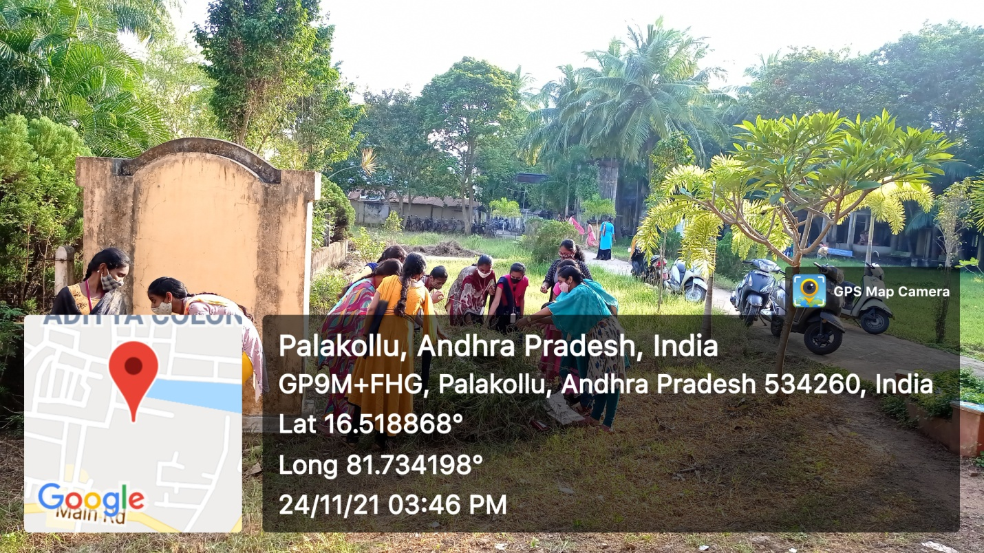

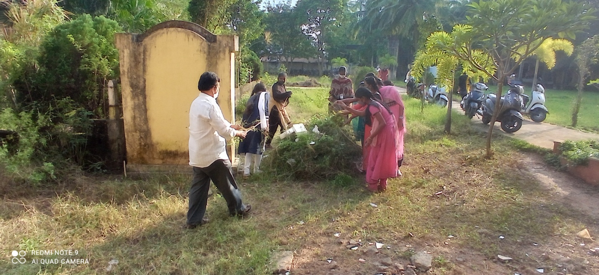

Staff and Students participated in Clean and Green Praogramme organised by Department of Physics on 24-11-2021

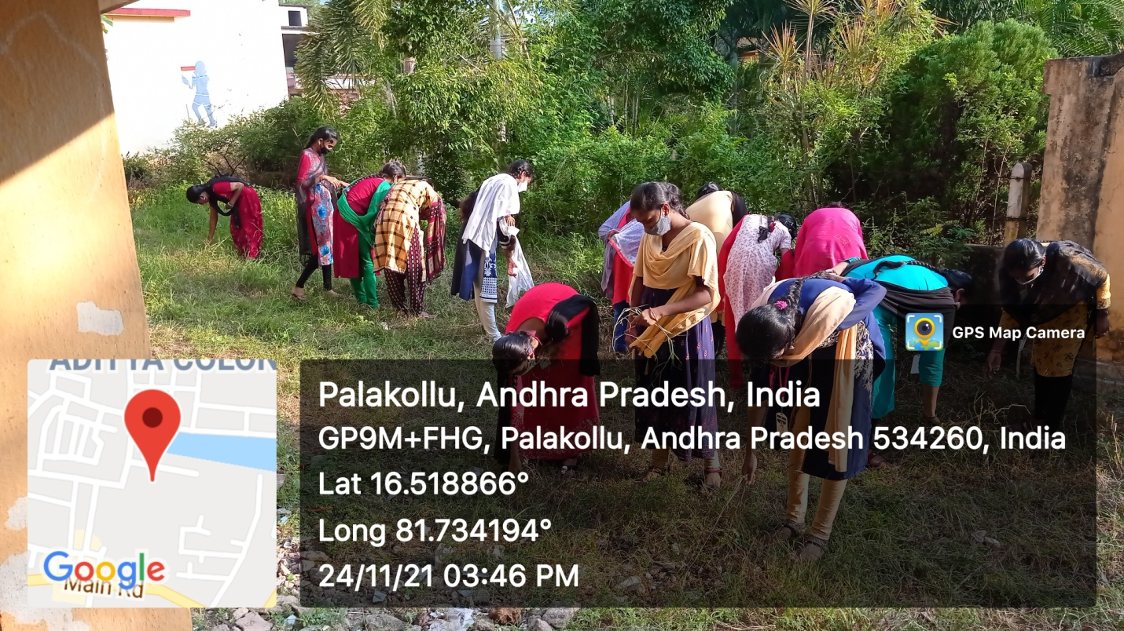

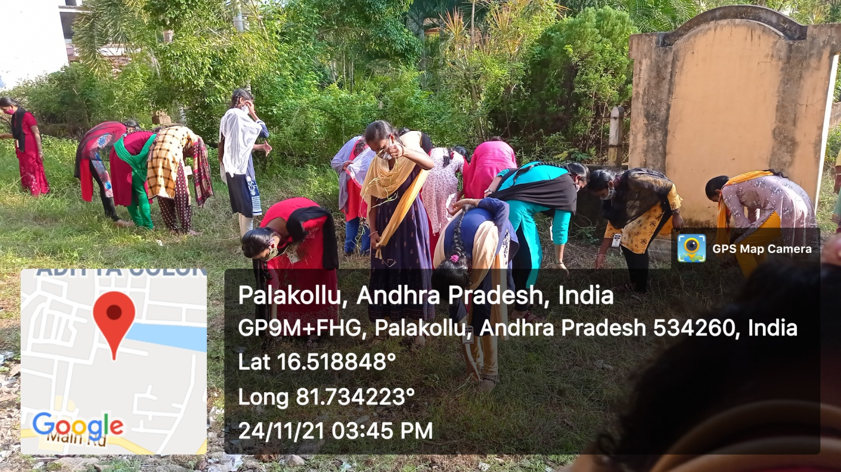

Staff and Students participated in Clean and Green Praogramme organised by Department of Physics on 24-11-2021

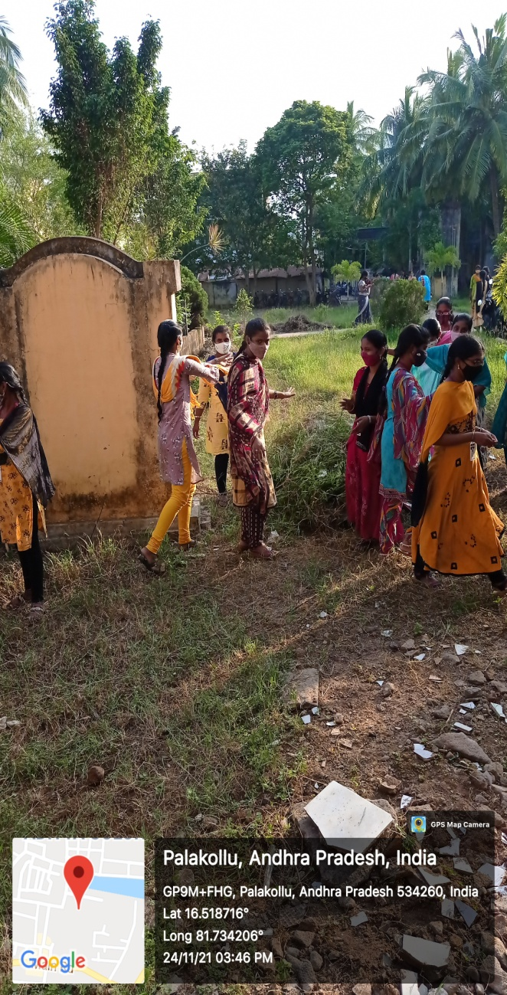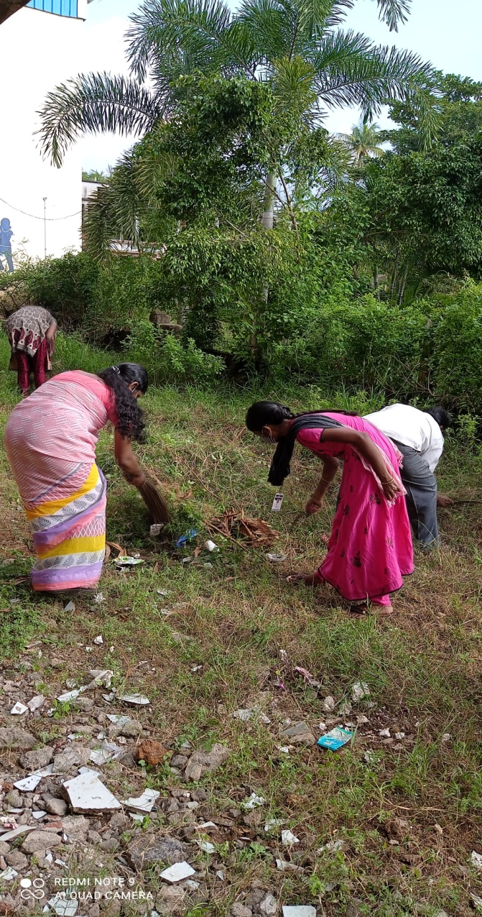

Staff and Students participated in Clean and Green Praogramme organised by Department of Physics on 24-11-2021

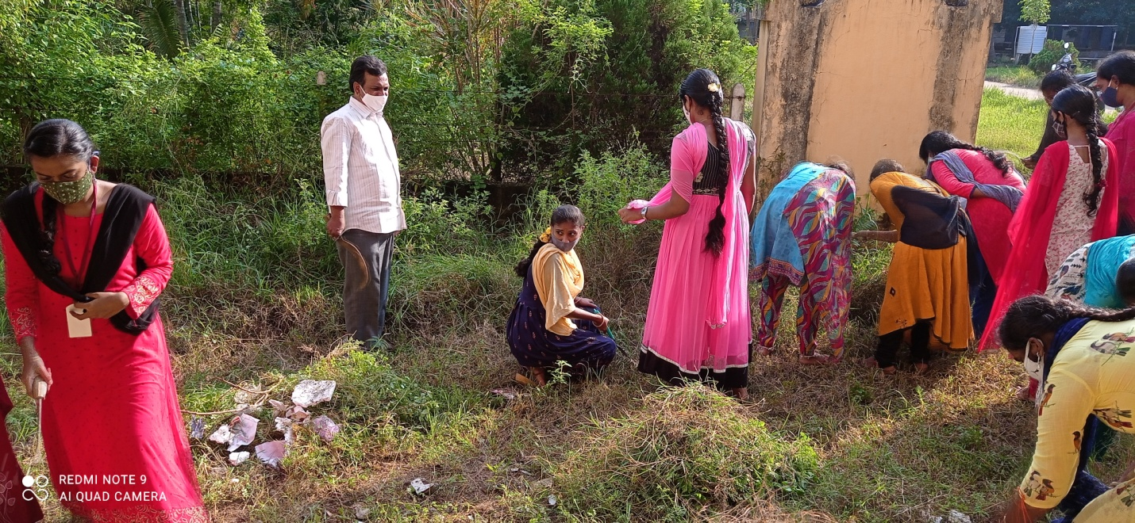

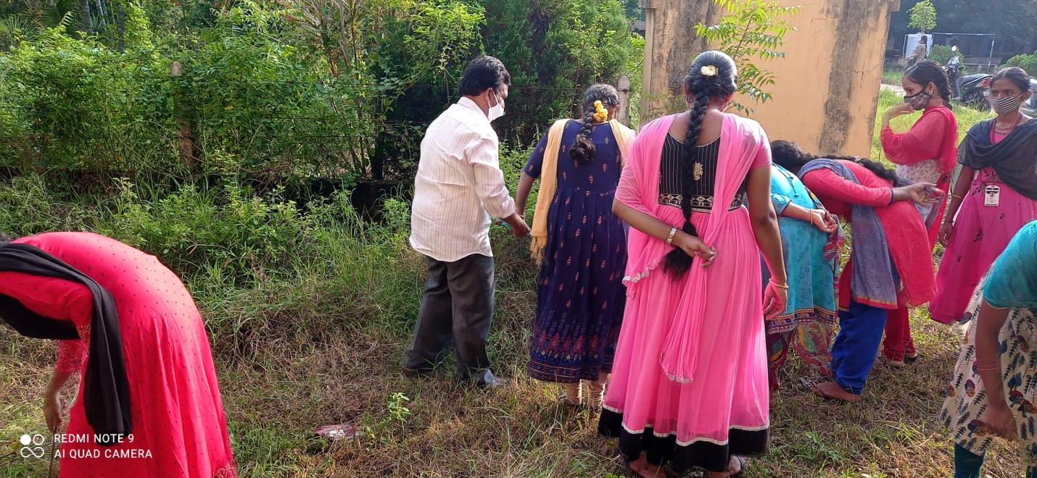

Staff and Students participated in Clean and Green Praogramme organised by Department of Physics on 24-11-2021

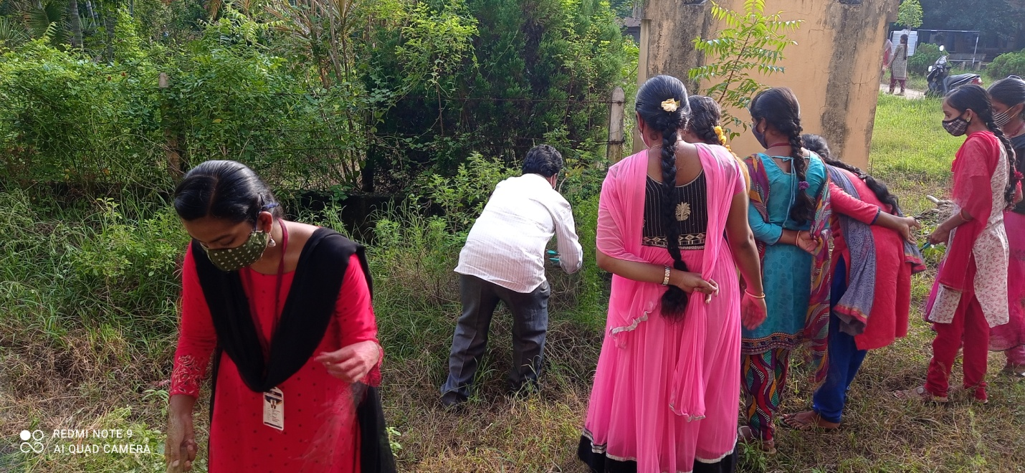

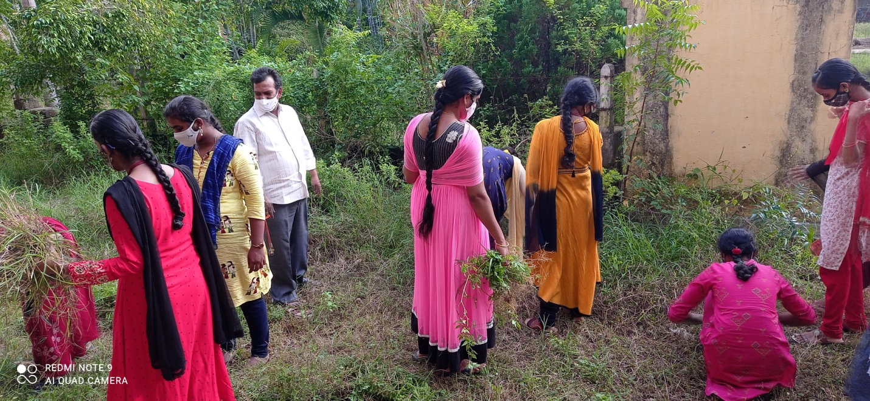

Staff and Students participated in Clean and Green Praogramme organised by Department of Physics on 24-11-2021

Clean and Green Programme on “CLEAN INDIA GREEN INDIA” (OR) “SWACHH BHARAT ABHIYAAN” was organised by the Department of Physics on 24th & 27th November 2021.

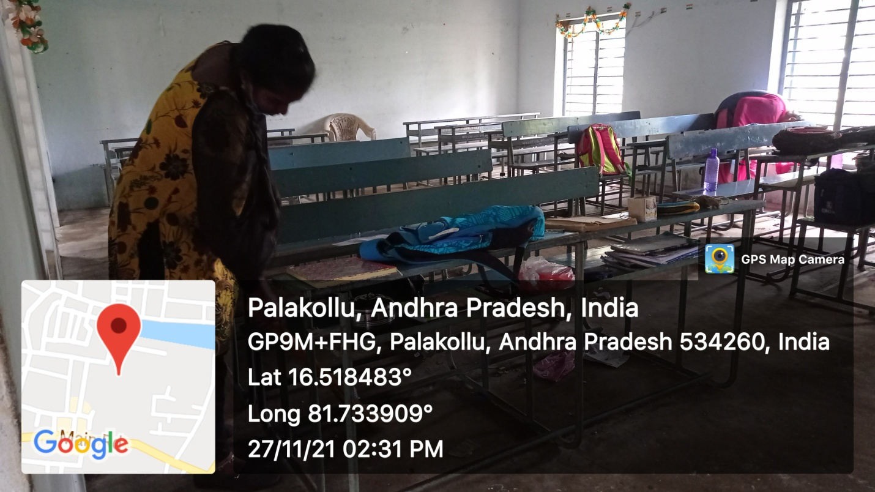

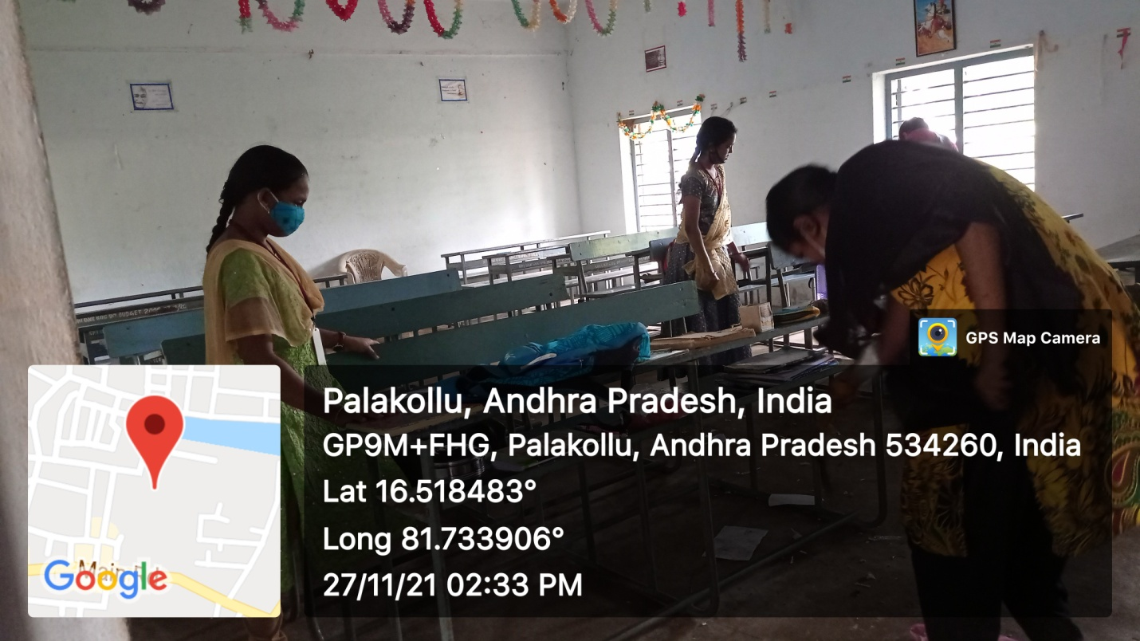
Staff and Students participated in Clean and Green Praogramme in Class rooms organised by Department of Physics on 27-11-2021

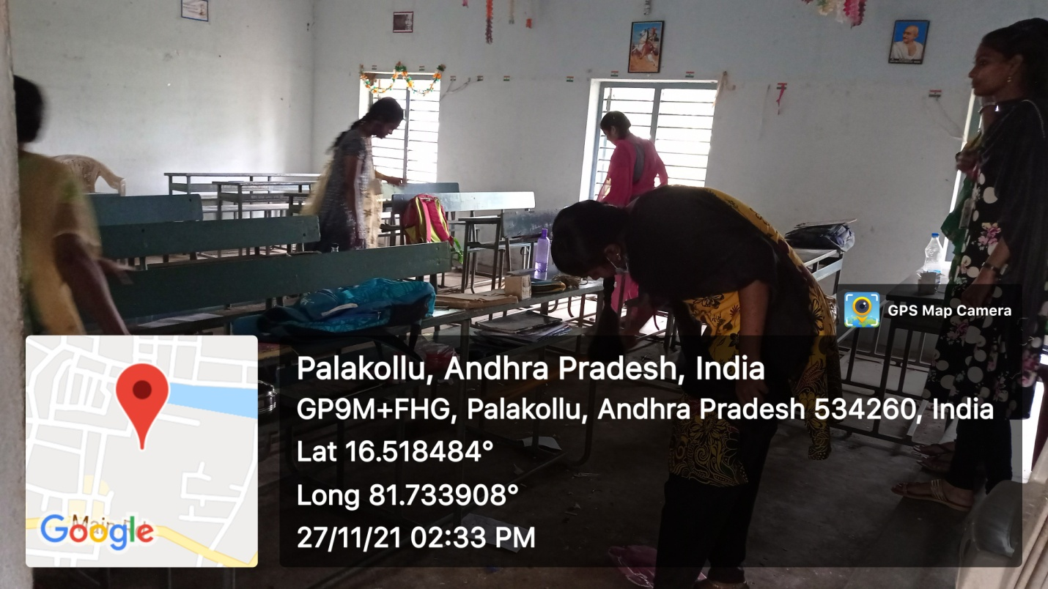

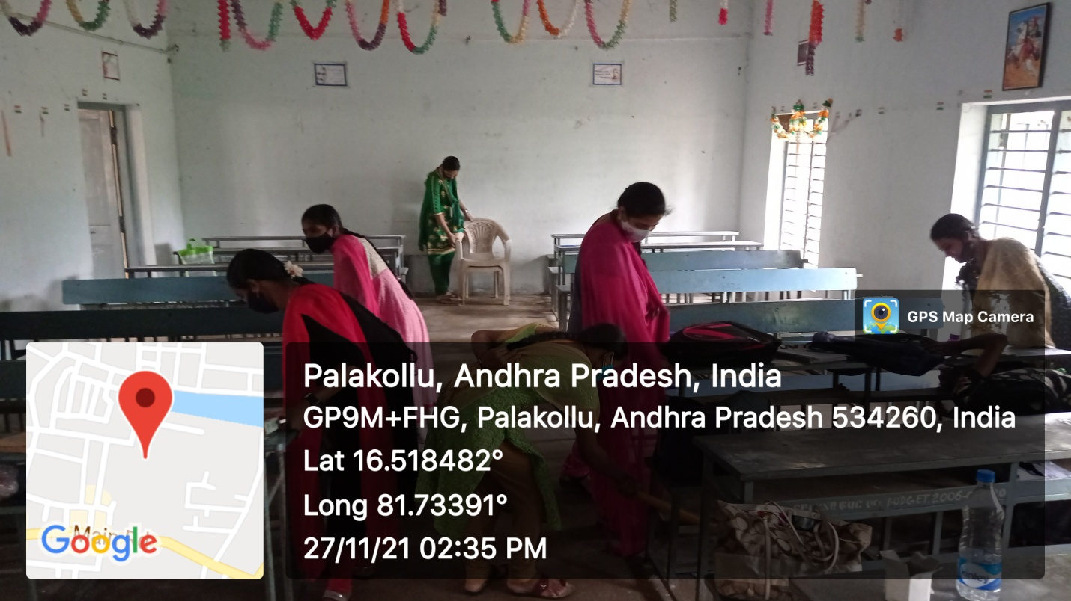
Staff and Students participated in Clean and Green Praogramme in class rooms organised by Department of Physics on 27-11-2021

Students attended guest lecture
Dept. of Physics, Dr.L Malleswara Rao and
Resource Person Dr K Ram Narayana

